

Contingency Management System
Interim Report

DT228
BSc in Computer Science

Leslie Ducray
C10327999
Richard Lawlor


Abstract

The purpose of this report is to document the research, design and development involved in the implementation of a contingency management web application. Though the application is developed to target the correction of drug misuse, the fundamentals behind the development could be used by other forms of behavioural economics systems. Contingency Management is a highly recommended and effective approach of physiological incentive based treatment. The approach aims to strategically treat alcohol and other drug addiction through offering tangible rewards. While the Contingency Management approach is clinically very effective and has proved valuable to many service users, the adaption to an automated web application will enable a quicker determination of the applied complex criteria and improve communication between treatment staff. The proposed System aims to automate a current paper-based system, removing the tedious and laborious act of processing a service user’s progression and providing a more ‘real time’ view of progression. This system aims to target two behavioural aspects; engagement and substance test results.
A main objective behind this system is to create a more automated approach to recording and calculating the service user's 'real time' reward status and entitlements (e.g. the voucher value of points accrued, "take away" medication privileges) in a far less laborious user interface than the paper based system which is currently employed in many treatment facilities.
Such facilities could include outpatient drug treatment centers, residential centers, prisons, the military, juvenile detention centers etc.

Table of Contents

To insert table of contents, the document must be formatted using heading styles throughout.
Click INSERT, INDEX and TABLES
Select Table of Contents, from the formats drop down list select CLASSIC

Table of Tables

To insert table of tables, the document must be formatted using heading styles throughout.
When a table is used in the report, ensure that the table style is used
Click INSERT, INDEX and TABLES
Select Table of Figures, select the options button
Ensure that the style checkbox is ticked (build table of figures from:) and ensure that the tables style is selected from the dropdown list
Select the Simple style of list layout

Table of Figures

To insert table of figures, the document must be formatted using heading styles throughout.
When a table is used in the report, ensure that the figure style is used
Click INSERT, INDEX and TABLES
Select Table of Figures, select the options button
Ensure that the style checkbox is ticked (build table of figures from:) and ensure that the figure heading is selected from the dropdown list
Select the Simple style of list layout

Chapter 1
Introduction

Section Heading
Body text

Style for code

Figure 1: Sample Diagram Title and number

Table 1: Sample table title and numbering
Headers: to insert header a section break must be placed to separate the chapters
Insert, Break, Section break types: Next page
The header can now be placed
View, Headers and Footers
Ensure that the same as previous icon is not on and format header as desired
Ensure that the page numbers are continued from the previous section :
Insert, Page Numbers, Format, Page numbering : Continues from previous section

Guideline of 25--30 pages (upper limit of 10,000 words) of content (excluding front pages such as table of content, and back pages bibliography/ appendices). The purpose of the content is to explain your progress to date. E.g. research, analysis, design, prototyping and future work.

Need to clearly describe the:
- Background research
- Clearly defined project scope
- Functionality of the project
- Challenges/risk
- Future work and project plan

Possible chapter structure

Chapter 1 Introduction and Background

Contingency Management is considered a psychosocial treatment system with a very high degree of evidence base.[1]
The approach aims to treat patients/service users by offering incentives to reward various types of behaviours. Service users of a contingency management system are user’s ‘actively’ rectifying their behaviour towards particular substances. These users form the purpose of the system. The system will allow users (professional
treatment staff/key workers)of specific centres (drug treatment;
residential, prisons, the military, juvenile detention centers etc.)to add/edit clients/patients (service users) to the system. Chapter 2 will uncover more reseach into CM ,the background of the approach and previous automated adaptions.

The motivation is to create an automated generic web application for staff working at a drug treatment facility which will allow them to admit, manage and administer the progress of service users within a CM system and to apply applicable reward and reset rules based on defined criteria.
The primary function of the system will be to apply a reward
(Contingency) process to Service users based on their drug use behavior, conduct, attendance and other criteria. The criteria applies logic
based on objectively verifiable results from clients' laboratory test
data, behaviour, meeting attendance etc.
This particular implementation of a contingency management system will group service users of the treatment- based centre into two
different streams, based on predetermined criteria (stability,
behaviour, extent of drug use).The two streams are ‘high Support’ and ‘Progress’. The reward protocol of each stream is
governed by different criteria.
Service Users can also be penalized for breaches of agreed
treatment contract including drug use, failure to attend meetings and
other regressions.
Additionally, the system will need to keep a full history of the
clients negotiated treatment plan, past records, notes from staff,
progress, rewards, and transactions.
As the system is based on the systematic application of earned incentives, services users will naturally accumulate these rewards. A large part of the application will be to record the transactions of service users. The transactions functionality will feature a balance of the clients earned rewards and eligibilities, ‘sanctions’ (loss of credits and ‘resets’) and a history of credits
earned and withdrawn. This particular approach will only monitor two types of behaviours as too avoid re-enforcing behaviours that to not comply with Contingency management behavioural principles.

The system will need to store and attain information on each service user regarding
- Meetings attended / general attendance
- Drug screening tests for various categories of drug use (e.g.opiate, benzodiazepine, stimulant, cannabis, alcohol etc.)
- 'Take Away medication ‘and other treatment privileges/ eligibilities
- Service User’s Treatment Stream
- Record History
- Rewards/Credit account – balance, history and transactions.
- Notes from staff

The web application will rely upon a rule based expert system to govern the underlying reward criteria.
Service users of the system are critiqued on two different behaviors, the explicitly mentioned two behaviors I will be mentioning and including in the development of the CM system is Attendance (to arranged meetings) and the service user’s results to substances tests. It is the results from these substance tests which progress and regress service user through the two streams. If a Service user consecutively tests negative on their substance tests, they will progress from ‘High Support’ stream to ‘Progression’ stream. With each negative tests the service user’s point accumulator increments which results in them being rewarded more. In situations where service users are testing positively for tested substances, there points accumulator is reset to its reset value (0). User do not earn points earned, but they will need to re-build their accumulators to be rewarded more. Likewise if a service user consecutively tests positive they will regress back to ‘High Support’ stream and/or be issued deadlines to test negative (date to clean). These dates are issued to give one weeks’ notice of the testing, extensions can be given. If the service user fails their ‘Date to Clean’ test, they are issued another date in a weeks’ time. These ‘Date to Clean’ dates are issued as cards ‘Green’, ‘Yellow’, ‘Red’ and ‘Black’, Once the black card is issued The Service User will need to re-assess their desire to continue with the CM program.
Attending meetings earns the service user the eligibility to ‘take away’ or ‘take out’ medication for self-administering at home. Missing attendance does not affect a service users standing in the program (ie. They will not regress back into the ‘High Support’ stream). The
The primary objective of this application is to provide a web application user interface for staff of a treatment centre employing the CM approach. The Web application will be required to correctly manage data requests and response from Client to server. The system functionality will need to correctly calculate the outcomes of the rule based system based on user input from attendance meetings and urine samples. Chapter 4 will cover the architecture and implementation process of the full system scope.

Chapter 2 Research
Research relevant to your project:
e.g. Current work being done in the area of your project; technologies researched; research of the problem being addressed.

Contingency Manageement

Initial research into the proposed project begun by studying and understanding the principles of contingency management, its application and it’s target environment. Contingency management is a psycho-social approach of managing a person’s consequences for their actions by rewarding or depriving them of incentives based on their behaviour. The CM process has a set of defined set rules which govern the reward process. Contingency management is a form of drug and alcohol misuse treatment, but its primary logic could be applied to many other behaviour economic purposes.
CM is primarily administered in treatment centres (drug treatment centres, prisons, juvenile detention centres etc.). The CM is applied by each new transaction of A) A service user’s attendance (attended, missed, missed with valid reason) and B) The result of their substance tests. These outcomes determine the amount of points they earn which are added to their balance, their eligibilities, their stream progression/regression and potentially their date to clean. For a service user to withdraw their earned credits they need to have at least a certain amount accumulated (in this instance €20), they also need to have tested negative in their most recent substance test. For a Financial user to approve the withdrawal of their earned credits, the fore mentioned requirements must be true.

Speaking with a clinical psychologist of a Dublin drug treatment centre, which employs a paper based implementation of the CM approach, the general use cases and the typical flow of process were discussed. When a service user (client/patient) is first admitted into the CM program, they are assigned to an agreed upon treatment stream. Initially the first stream is the first stream of the progression, in this instance, the ‘High Support’ stream. Each stream offers a different level of rewards and likewise a different level of penalty for misbehaviour. The service user’s details are elicited and recorded.

Through personal correspondence with Dr. Nancy Petry, leading authority in contingency management and the developer of the low-cost contingency management treatment approach; the project proposal was discussed.
In regards to previous implementation attempts, Dr. Petry had this to say “Several groups have attempted to develop automated CM programs, but none have been widely implemented in practice.” Dr. Petry went on to discuss the previous short falls of previous implementations she has been exposed to and explained corrective measures at trying to better ensure a correct implementation.
“Some of the problems have been that each clinic seems to want to implement CM in its own way, and the programs developed thus far have not been able to accommodate issues such as different reinforcement magnitudes and types (vouchers vs prizes vs stars exchangeable for items), different attendance structures (which is less of an issue for opioid replacement treatments relative to outpatient care), different durations of CM interventions, and excused absences.” Many of these issues had been taken into consideration in the initial proposed approach, but the comments stated offered more definition and confirmation for the planned implementation. Dr. Petry continues on to state issues regarding valid reasons for being absent from arranged meetings and samples “Because the evidence-based CM programs have escalating reinforcers for sustained abstinence, the programs developed to date have not been able to incorporate this feature appropriately given the real world issues that arise (e.g., in terms of missed samples for legitimate reasons etc.).”. Previous implementations have enforced the CM criteria too rigidly without offering an override or exception to legitimate reasons of absence, thus penalizing the service user ‘unfairly’.

Application medium

The decision to implement a web application opposed to a native application /standalone software application of mobile device app was decided based on a few considerations:

- Where will the users use the application?
Typically users of the system will be based in offices or lab environments where they can record test results/notes/attendance.

- Who will the typical users be?
Typically the users of the system will be physiologists/professional treatment staff /key workers with granted access to the system.
- What medium/technology will the users have?
In a treatment centre or correctional facility, typically the administration staff would have a personal computer/laptop for keeping records. In many cases, due to the one-on-one nature of the interaction between a service user and a member of treatment centre staff, information would be taken down during the meeting.
- What will be the most accessible means of distribution for the system?
Due to the nature of the confidential and sensitive information stored, the system will need to be securely and safely distributed. A web application hosted on a local and secure network would be cater for this requirement. Web applications allow for more diverse client technology, as they can be run and rendered on many different environments. The user interface can be easily and efficiently designed using HTML/JSP and can be enriched with native client side technologies.
If any issues or updates arise, the new release can be deployed near seamlessly opposed to updating a software application which could require acquisition from an ‘app store’ and installation.

- How will this application help? If implemented correctly, this application will serve a great help to staff of a treatment centre, aiding them by bypassing the act of having to apply the CM criteria and provide feedback in near real time. It will provide with them with a much more efficient record keeping facilities.

Database

As the system will rely quite heavily on data storage, a reliable and efficient database is needed. The design and implementation of the database is required to be quite sophisticated in its associations. As the business logic of the web application is firmly based on the governing rules of Contingency management, implementing the database to dynamically aid the rule based system will greatly improve the maintainability of the system.

The structure and nature of the data storage required for the proposed CM system is relatively rigid tabular format. The associations between table entities will serve the database systems primary function for storing and retrieving data. Any change or volatility of the data model/schema is unlikely expected, as the associations between table entities will be closely based on the principles of CM and information required, and the entity attributes will be designed to allow a certain degree of dynamics.
With this statement in mind, the need for the likes of a NoSQL database such as MongoDB would serve little benefit. NoSQL databases employ a less constrained data model that allows for retrieval and storage of data in a more flexible manner. Where relational models spate data into various associated tables joined by identifiable keys, document orientated NoSQL databases such as MongoDB aggregate the data into one particular record for storage, thus removing the need for entity relationships.
A relational database such as MySQL would suit the nature of a CM system, offering a simple and set approach for storing, querying and retrieving data. MySQL has the power to employ the option of data warehousing which could be an expansion of analytical and report generations for the application in the future. MySQL is one of the leading popular open source Relational database managers, offering in addition a MySQL server and the workbench for development. As the scope of the application by design will be limited to the local network of treatment facility, where the amount of traffic to and from the database will remain relatively low and the expected wish to scale the database is non-existing, a MySQL database is ideally suited.

Web Technology

Java Enterprise applications using the Spring Framework: research into architectural layers/patterns. Data Access Objects- manage connections to persistent data (eg. The database). Act as an intermediate layer between client and data source, so data sauce remains hidden from client. Using java beans to store information retrieved from database, the application can query and use the beans as a data source.
Facades are used as a remote access layer to prevent revealing business components to clients. They encapsulate the components of the application’s business model, which clients can then access.

Servlets and services, hosting the servlet services independent of the servlet classes allow the access and use of service and functionality to other business tier objects.

Rule engine

Deciding on a rule based expert system to incorportate into the system was dependant on a few factors
- Will it integrate well with the existing chosen technologies?
As the current web application technologies and languages decided are Java and mysql, the middle wear needs to be able to interact with the select rules engine.
- Licensing, is the software open source or is purchased licence required?
- Is a Rule engine necessary? As the primary business logic of the system is focussed on applying criteria to know facts, a rule engine could be very effective in structuring and optimizing the calculation process.

Initially JESS (Java expert system shell) was going to be the preferred option to incorporate into the system, until Licensing was looked into. A personal enquiry was made to the Software Licensing Administrator at Sandia National Laboratories requesting information on obtaining a licence for this particular project.
An academic licence was attained under strict terms and conditions that the academic licence is restricted only using JESS on a project specific basis for academic and non proprietary and/or commercial research or development.
Open source and Java intergratable rule based engines were researched and compared. Drools is an open source forward chaining inference based rule management system. Drools employs an enhanced version of the rete algorithm and can easily be incorporated with in a java application. In addition to the rule engine, the Drools software also includes rule visual aids which illustrate the flow of the rules which will aid in the development.

http://docs.jboss.org/drools/release/5.2.0.Final/drools-expert-docs/html/

Chapter 3 Design Methodologies

The design and implementation of this project began at a database level. The system is very dependent on the structure of the database entities and their associations. The database is firmly based around a Contingency management paper-based system. There were multiple implementations of the database before further web application development would begin.

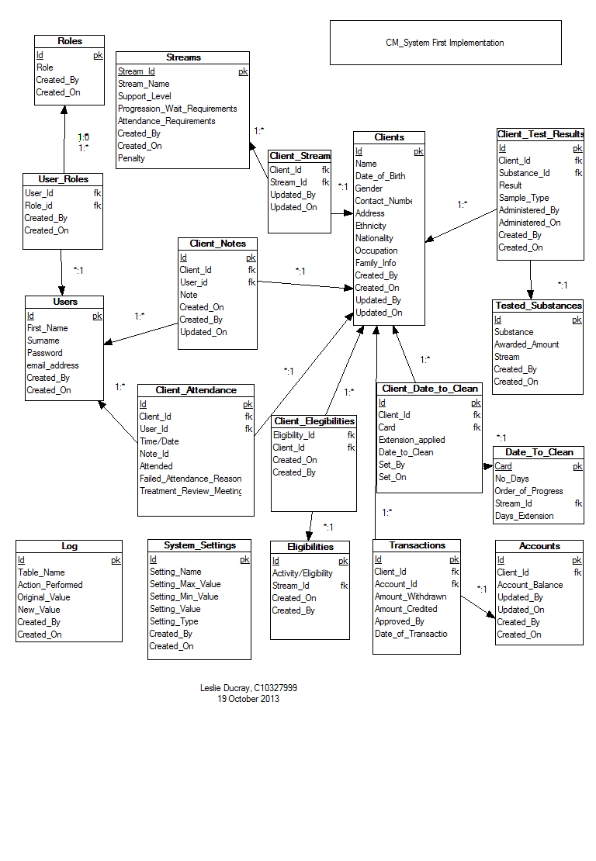
Figure 1: First Implementation
The first implementation of the database was a rough design model recording all the necessary attributes, keys required and the relationships between entities. The first implementation included a full schema logging table, this is removed in later implementations, instead each table record will store the user key and the date associated with its creation and this can alternatively be used as a log. All associations to the ‘User’ table are not recorded in the above diagram, as the relationship is repeat for each table, and the readability of the diagram is impaired with each association displayed, figure 2,below, illustrates the associations between each entity more explicitly. Figure 3 expands on Figure 2, illustrating each entity’s attributes.

The database schema is composed of sixteen tables catering for storage of all relative information. A summary of each table is as follows:

- User – The User table stores all static general information related to a member of staff of the treatment facility.
- Role – The Roles are permission statuses for the system.
- User Role – the joining association assigning a role to a user.
- Service User/ clients – This table represented as Service user or Clients stores all general and static information regarding a service user.
- Service User notes – this association table joins a service user and user where the user has recorded a note on the service user.
- Service User attendance – records a service users meeting with a user. This table records if a service user fails to make an arranged meeting and whether they have a legitimate excuse (which will spare them penalization when CM rules are applied).
- Substance – recorded information regarding substances and their affect on the CM criteria.
- Service User Substance Result – This table forms an associative history for each service user and their substance tests, storing the result, date administered, points earned etc.
- Stream – this table stores general information regarding the CM streams- different levels of progression within the CM process.
- Service User Stream – The stream associated with a service user. Their current level of progression.
- Account – A service user’s account stores the balance of their earning.
- Transactions – the records of all rewards earned/credits and withdrawals/debits made to a service user’s account.
- Eligibility – the information regarding all Eligibilities – such as ‘eligible to with draw’ , ‘outings/visits’ , ‘take outs’.
- Service User eligibility – an association of which service users have which eligibilities.
- Date to clean – this table stores the information regarding date to clean rules. ‘Date to Clean’ is a date set by a user of the system assigned to a service user to test negative in a substance test.
- Service user date to clean – A recorded history of service users and their assigned dates to be clean, if extensions were given, consecutive failures.
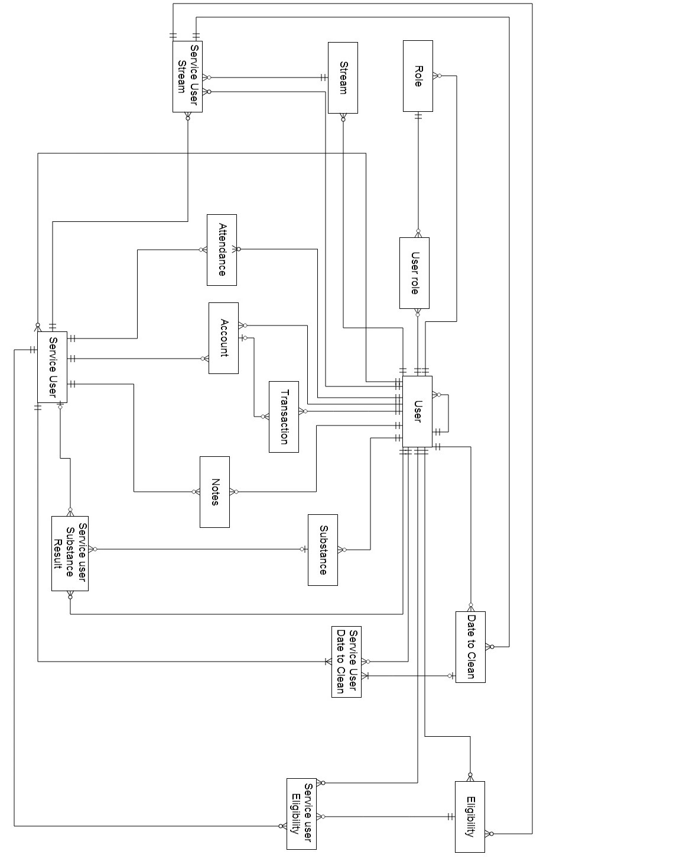
Figure 2: Full representation of associations between entities
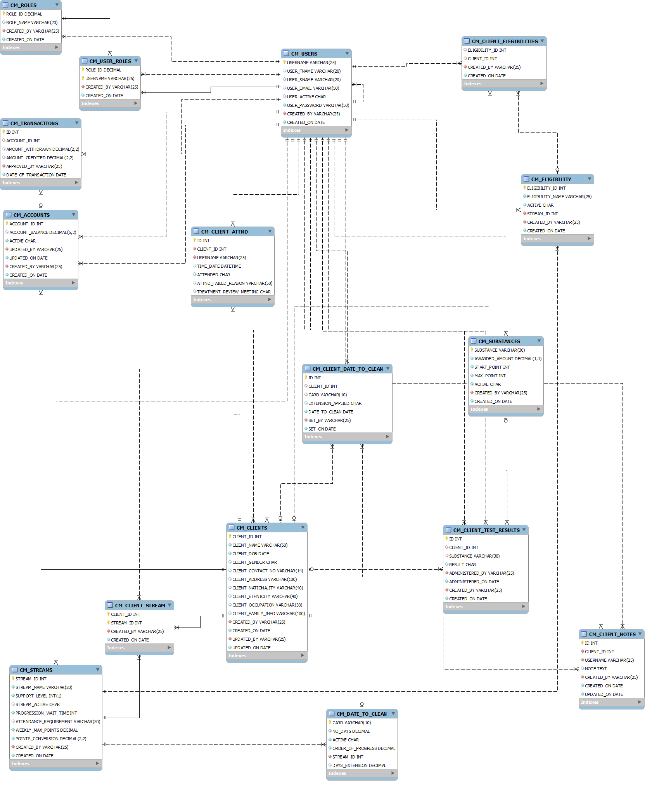
Figure 3: The current database schema. *Clients are Service Users

Once the underlying database structure was of confident design, the design and planning began on the expectations of the web application. These expectation are represented in the use case featured in Figure 4. Figure 4 defines the three user (actor) roles of the system:
- User, the default role of any active user of the system. This role permits a user to add new clients/service users, edit existing ones, record test results and attendance which in term applies the contingency management criteria.
- Financial User, a role assigned to a user permitting them to view the account of an service user and approve the withdrawal and/or assignment of rewards to a service user/client.
- Admin, is the administration role. This role permits a user to add/edit users of the system.
User’s of the Financial and admin role are permitted to all actions of the default user role.

The system actor forms the business logic and control of the application. The system will be required to:
- Establish a connection with the database.
- Respond to user requests.
- Validate user login and assign roles.
- Manage the user session.
- Process queries/updates/transaction to database.
- Calculate and apply the Contingency management rule criteria.

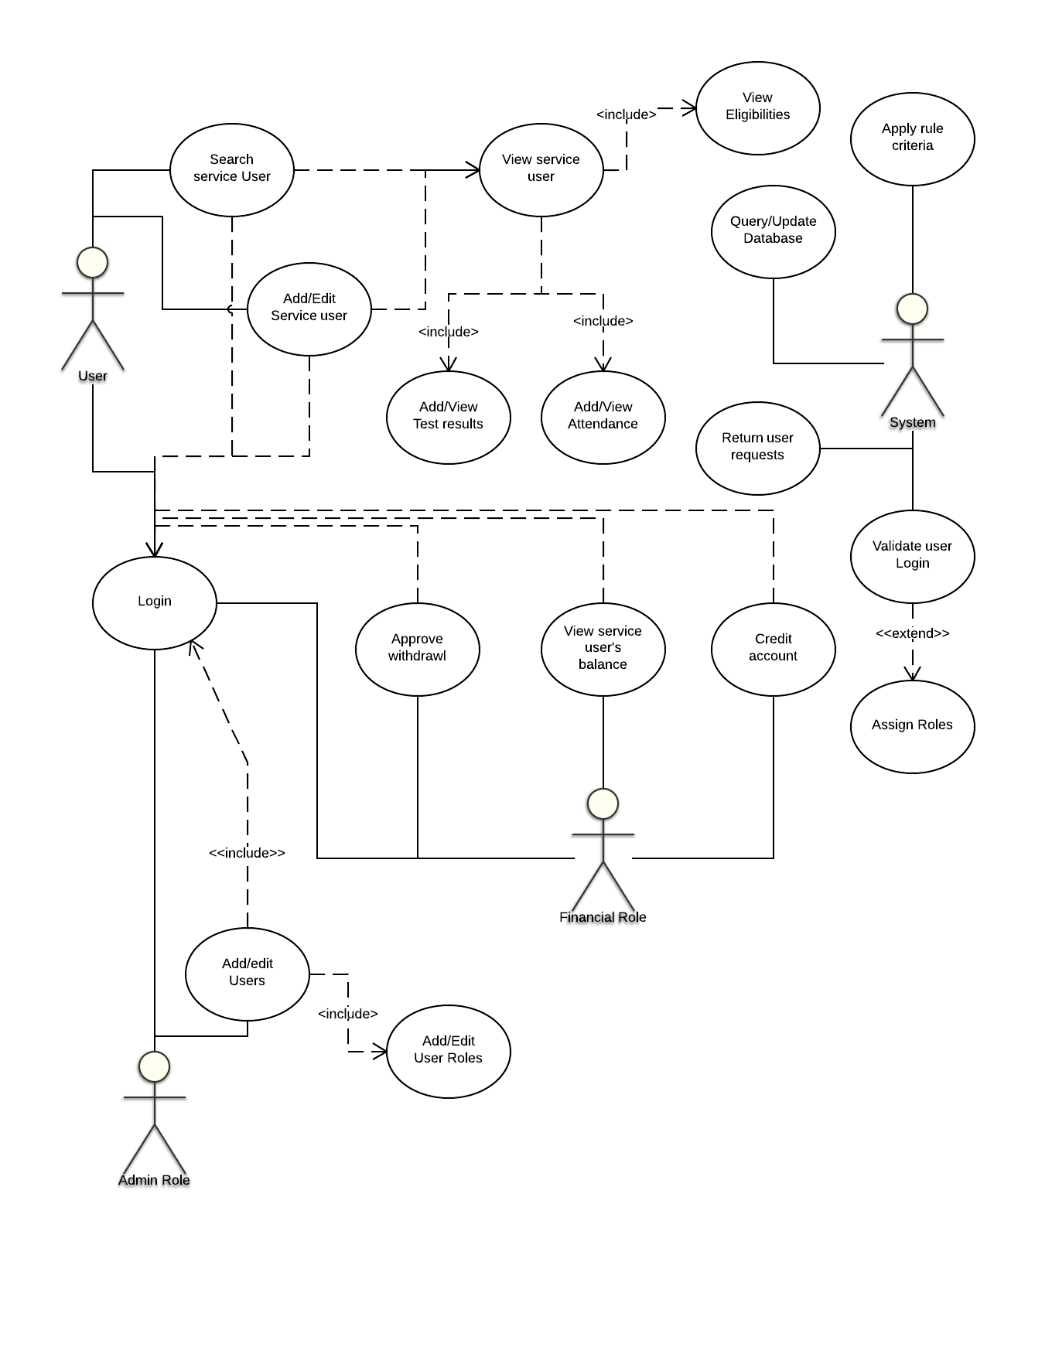
Figure 4: High level Use Case of system

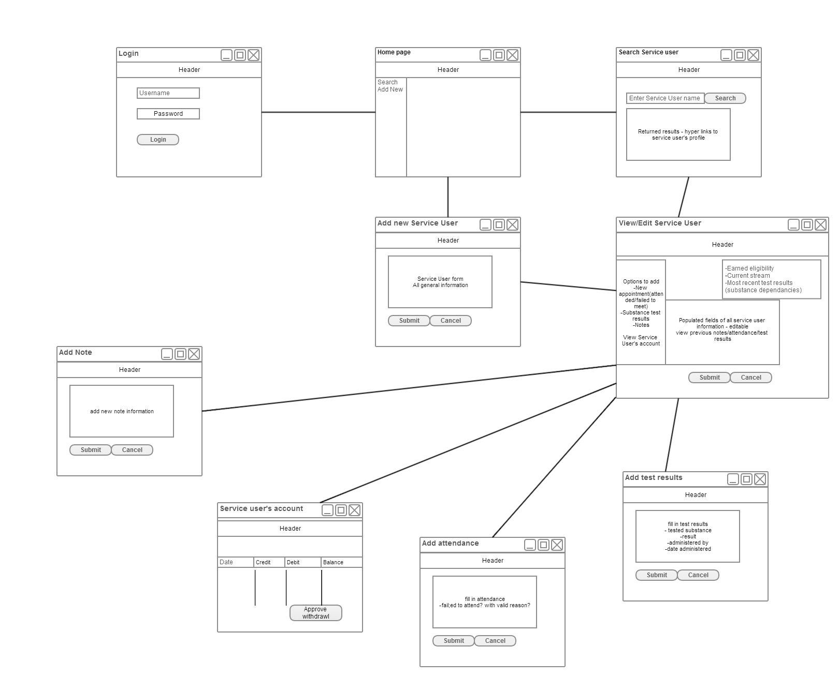
Figure 5: Front End Horizontal prototype

Figure 5 illustrates the conceptual layout of the web application and the flow between pages as presented to the user.
The design methodology chosen to guide the implementation of this application is the Agile design methodology and aspects of Scrum applicable to a single full project developer. This methodology feels most suitable to the application, allowing the user to plan sprints/iterations (an independent aspect/part of the system to be developed), design and analyse, implement, test and evaluate. The full system plan is divided up into independent sprints or iterations.
This allows an assessment to be performed at each iteration of a particular aspect of the system to review progress and priorities and to test and evaluate current implementations. The Agile and Scrum encourage an incrementing implementation design and development process. Using this methodology, the progress and implementation of the application can consistently be assessed, and each aspect of the system will be concluded instead of developing multiple incomplete aspects. Having a complete system sprint full functioning will aid in testing and evaluation, allowing target users to review and provide feedback for consideration, improvement and rectification.

With the general required functionality of the system established, the web application was divided into multiple independent sprints for design and development. These sprints will be discussed further in Chapter 4 Architecture & Development.

Chapter 4 Architecture & Development
Technical architecture; environment; languages; vertical prototyping
..

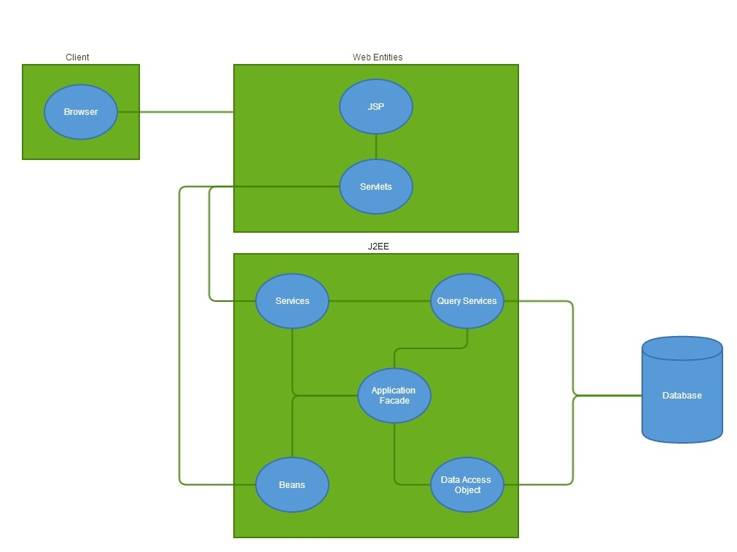
Technical Requirements

Personal computer.
Eclipse IDE J2EE edition.
Apache Tomcat.
MySql server and workbench.
Web browser.
Xampp server – hosting mysql and tomcat locally.

Technologies

Pl/SQL.
Java – J2EE. JDBC mysql connector
Java Servlets and JavaBeans. http session
JSP/HTML/JavaScript/XML.
JESS, Java rule engine.

All images composed using Lucidchart.com and gliffy.com
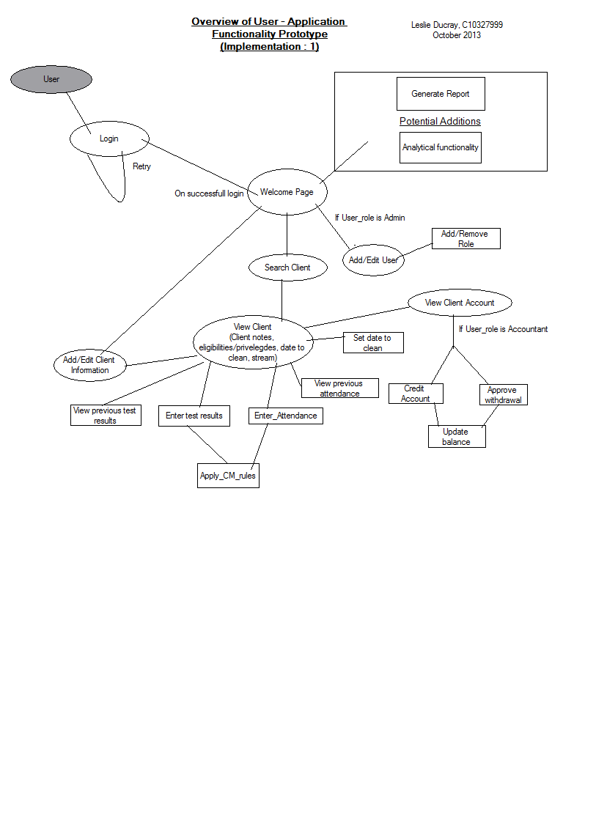

Chapter 5 Challenges, future Work & Project Plan
What are the key challenges/risks that you see for your project? What is you testing plan? evaluation plan? Project plan and key dates until completion?

Challenges
The largest foreseen challenge in the future of the application will be implementing and correctly evaluating the CM rules within the system and applying them to the application. Flow charts and decision diagrams displaying the reward criteria have been designed to aid this development process and the Drools language and model are being studied.

In the coming months, priority is placed in the continual iteration of the devised system sprints to continue developing the system modules and ensuring they are thoroughly tested.

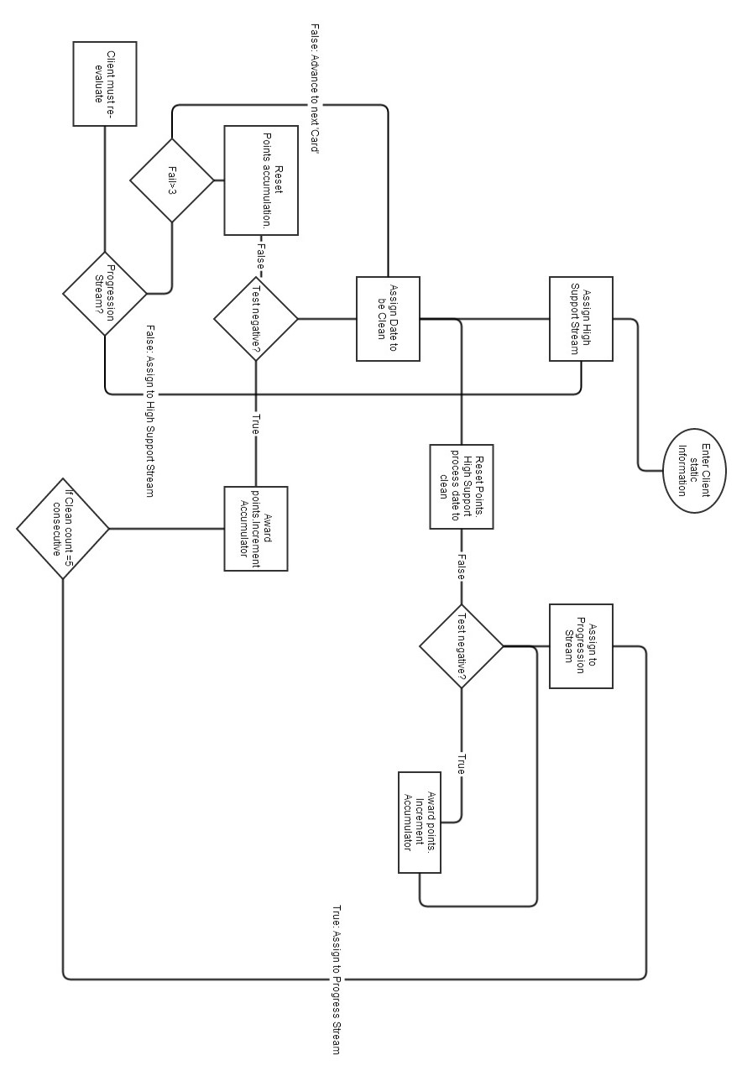
Figure 6: CM process for rewarding/resetting service user's tested samples for substance abuse

Testing
Primary testing will take place during each sprint iteration as with the process of the Agile design methodology. Following pre-written test cases, each aspect of the system will be thoroughly tested based on expected outcomes and intended design. EACH Implementation will undergo a full UAT (User Acceptability testing) ensuring the required system requirements are met and correctly implemented.

Evaluation
Evaluation will be primarily based on the accuracy and correctness of the CM rules applied to the events of the system.

Future Plans
December : The plans for December is to continue systematically designing, developing and testing independant components of the system, and with each iteration incorporating them into the growing development. By the end of the year it is expected to have the majority of the system middle wear developed. This will include all non-rule based system functionality (eg. Interactions with database, queries, inserts, updates, form processes , responses to client requests).

January: Implementation of the Rule based system using Drools and applying it to the functioning system.

February : Full system tests and UAT. Evaluate with real users of a CM paper system and gauge
March: Will be Focussed on polishing off and improving the front end user interface, purely design and layout focussing on the heuristics and HCI properties.

Being ever vigilant of the suggestions and critsims from Dr. Petry.

Bibliography; Appendices;

1) Give them prizes and they will come: Contingency management for treatment of alcohol dependence.
Petry, Nancy M.; Martin, Bonnie; Cooney, Judith L.; Kranzler, Henry R.
Journal of Consulting and Clinical Psychology, Vol 68(2), Apr 2000, 250-257. doi: 10.1037/0022-006X.68.2.250

